One Site Case Study – 2FA Login System

User Story
As a | Registered user of http://mywebsite.com
I want | To securely log in using a password and an OTP
So that | My account remains protected from unauthorized access
Acceptance Criteria | - On http://mywebsite.com, system shall display ‘Login’ hyperlink on the homepage (refer Appendix 2: Display ‘Login’ Link wireframe and Appendix 3: Data Table for ‘Login’ Link).  - On click of ‘Login’ hyperlink, system shall navigate the user to the Login Page (refer Appendix 4: ‘Login Page’ Wireframe and Appendix 5: ‘Login Page’ Data Table).  - System shall allow the user to enter Email and Password.  - On click of ‘Login’ button:  4.1. If credentials are valid, system sends an OTP to the user’s registered email/phone.  4.2. If credentials are invalid, system displays inline error messages (refer Appendix10: Inline Error Messages).  - System shall navigate user to the OTP Page (refer Appendix 6: ‘OTP Page’ Wireframe and Appendix 7: ‘OTP Page’ Data Table).  - System shall validate OTP upon submission.  6.1. If OTP is valid, system shall navigate the user to ‘Login Successful’ page (refer Appendix 8: ‘Login Successful’ Wireframe and Appendix 9: ‘Login Successful’ Page Data Table).  6.2. If OTP is invalid or expired, system shall display inline error messages.  - On click of ‘Cancel’ command button at any point, system shall discard all inputs and navigate the user back to homepage.

Use Case
Use Case Name | User Login with 2FA
Use Case Number | 2.00
Primary Actor | Registered Online User
Use Case Story: | Enables a registered user to securely log in using password and OTP
Trigger | User clicks on ‘Login’ hyperlink displayed on http://mywebsite.com
Pre-Condition | User is already registered
Post-Condition | User is successfully logged in and directed to their account dashboard.
Extension Points | Forgot Password use case
Primary Flow | Title: User logs in successfully
Primary Flow | Actor Action | System Response
Primary Flow | 1) User clicks ‘Login’ hyperlink. | 2) System navigates user to Login Page (Refer Appendix 4: ‘Login Page’ Wireframe and Appendix 5: Data Table)
Primary Flow | 3) User enters Email and Password. | 4) System validates credentials and sends OTP (Refer Appendix 6: ‘OTP Page’ Wireframe and Appendix 7: Data Table)
Primary Flow | 5) User enters OTP.
  6) System validates OTP and navigates user to dashboard (Refer Appendix 8: ‘Login Successful’ Wireframe and Appendix 9: Data Table)
Alternate Flow 1 | Title: One or more validations fail
Alternate Flow 1 | Actor Action | System Response
Alternate Flow 1 | 1)User enters incorrect Email/Password/OTP | 2) System shall display inline error messages. (refer Appendix 10 : Inline Error Messages )
Alternate Flow 1 | 3) Go to Step 3 of Primary Flow
Exception Flow 1 | Title: User cancels login process
Exception Flow 1 | Actor Action | System Response
Exception Flow 1 | 1)User clicks ‘Cancel’ button on any page | 2) System discards data and navigates back to homepage (Refer Appendix 1: Homepage Wireframe)

Supporting Information

Appendix 1: ‘2FA Login’ Process Flow

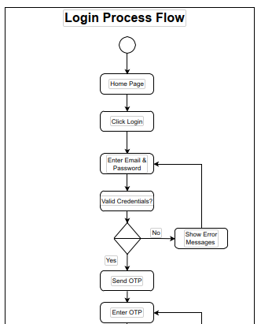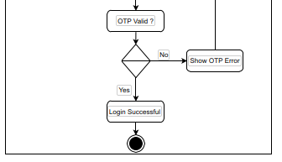

Appendix 2: Display ‘Login’ Link wireframe

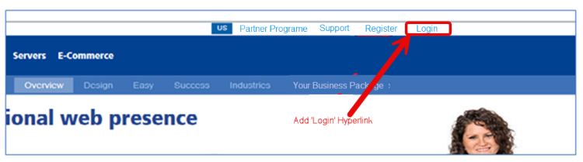

Appendix 3: Data Table for ‘Login’ Link
ID | Field Name | Field Type | Content | Required Field?
1 | Login | Hyperlink | N/A | No

Appendix 4: ‘2FA Login’ Wireframe
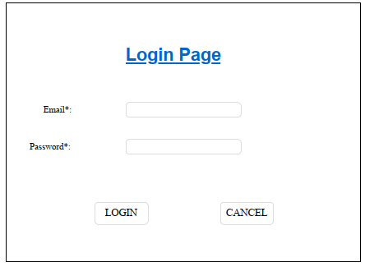

Appendix 5: ‘2FA Login’ Page Data Table

ID | Field Name | Field Type | Content | Required Field? | Notes
1 | Email | Text Box | Alpha-numeric | Yes | User must enter valid email format
2 | Password | Password Box | Alpha-numeric | Yes | Must be 8–16 characters, masked input
3 | Login | Command Button | N/A | N/A | Submits entered credentials
4 | Cancel | Command Button | N/A | N/A | Clears input and returns to homepage

Appendix 6: ‘Enter OTP’ Wireframe
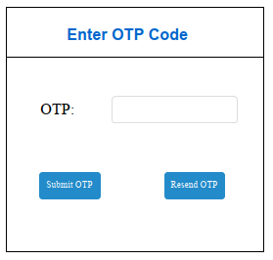

Appendix 7: ‘Enter OTP’ Data Table

ID | Field Name | Field Type | Content | Required Field? | Notes
1 | OTP | Text Box | Numeric | Yes | 6-digit OTP input field
2 | Submit OTP | Button | N/A | N/A | Validates OTP and proceeds if correct
3 | Resend OTP | Button | N/A | N/A | Sends a new OTP (limit: 3 attempts)

Appendix 8: ‘Login Successful’ Wireframe

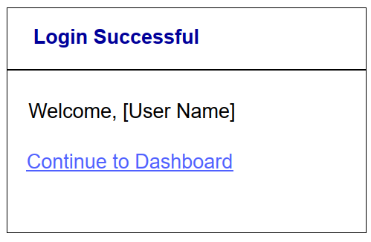

Appendix 9: ‘Login Successful’ Page Data Table

ID | Field Name | Field Type | Content | Required Field?
1 | Login Successful | Text | Welcome message | No
2 | Continue to Dashboard | Button | Link to dashboard | No

Appendix 10: Inline Error Messages

Failed Validation | Error Message Displayed
Missing Credentials | <Field Name> is required.
Invalid Credentials | Incorrect username or password.
OTP Expired | Your OTP has expired. Please request a new one.
Invalid OTP | Incorrect OTP entered. Please try again.

Questions to be asked to SMEs
- What are the current login steps followed by users?
- What security concerns have been reported with the current login system?
- Should the OTP be sent via email, phone, or both?
- What is the expiry duration of the OTP?
- How should the system handle incorrect OTP entries?
- Should users have the option to resend OTP?
- What validations are necessary on the login and OTP pages?
- Should there be a maximum number of OTP retry attempts?
- Should the user be redirected to the home/dashboard page upon successful login?
- What error messages should be displayed for different failure scenarios?

